The Ferns of Winter
Location: Brandywine Creek State Park, Woodlawn Trustees Preserve
Distance: ? miles (in-and-out hike)
Season: All
Fees and Permits: None
Other Maps: Brandywine Creek State Park, USGS Wilmington North quadrangle

Directions to trailhead: ***

A survey in 1974 found six different species of fern growing on this slope; a seventh species has since been observed in the vicinity as well. Of the seven, four retain their foliage throughout the winter and can be sought for throughout the year. In fact, winter makes these ferns easier to find and identify by removing concealing underbrush.

The Winter Hike

Start at the trailhead at the end of Garden of Eden Road, parking in the lot in back of the Jewish Community Center. The trail leading downhill from here is an abandoned extension of the road. As you move down the trail, the first ferns you will probably see along the roadside during winter are Christmas fern, Polystichum acrostichoides. As is typical in ferns, each long, narrow leaf, called a blade, is cut into many smaller pieces, called pinnae. If you carefully examine the pinnae of Christmas fern, you will see that each one is held to the stalk (technically called the rachis) by a narrow stem only; there is a projection at the base of each pinna pointing towards the tip of the rachis, as if the pinna were a hand and the projection an outstretched thumb. These ferns are quite common in the area and seem to do particularly well on steep slopes, where their leaves flatten in the winter and help retain fallen leaves and soil.

About 0.15 miles in from the trailhead, look for a rock on the right side of the rail with a crack cutting across it near the base, sprouting ferns. Some of these are Christmas ferns, but look for the ferns which, though similar to Christmas fern, have narrower, long blades and shorter pinnae. Note also that the rachis of these ferns is a dark reddish-brown, rather than green. These are ebony spleenwort, Asplenium platyneuron.

At [distance], turn left along a trail cutting across the hillside, running parallel to a stone wall.On either side of this trail, you will begin to see ferns with a considerably more dissected leaf and the stereotypical “lacy” look of ferns; here the pinnae are themselves subdivided into smaller sub-leaves called pinnules. These are wood ferns, from genus Dryopteris. There are many species of Dryopteris, many of which hybridize with one another and can be difficult to distinguish. In this case, we only have to distinguish between two evergreen species of Dryopteris: D. intermedia, the intermediate wood fern, and D. marginalis, marginal wood fern.

Marginal wood fern is uncommon in Delaware, vastly preferring the rocky slopes of the Delaware Piedmont over the sediments of the Coastal Plain. Here in the park, it is locally abundant. The most straightforward way to distinguish it from intermediate wood fern is by examining a fertile frond. Examine the backs of fronds until you find one with little brown, raised speckles on the back; these are the sori, clusters of bodies that release the fern's reproductive spores. In D. marginalis, the sori will be at the very edge, or margin, of the pinnule, giving the fern its name. Looking closely at the D. marginalis leaf, you can also see that it is cut into pinnae and pinnules but no further; the pinnules are rounded with smooth edges.
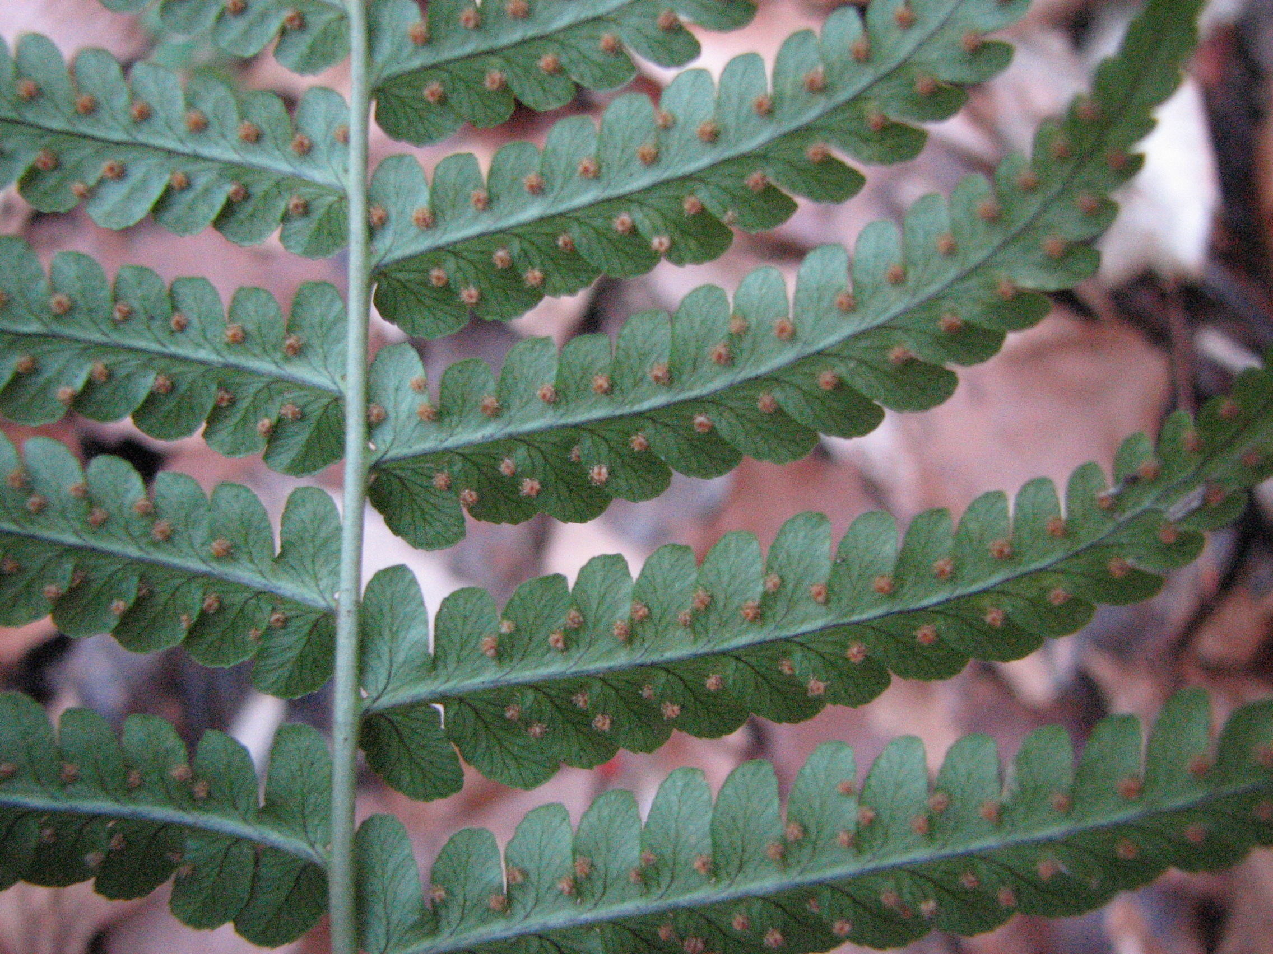Illustration 1: Back of a fertile frond of marginal wood fern.
Eventually, as you walk along the trail, you will probably come across intermediate wood fern as well. D. intermedia has sori that are closer to the middle than the edge of the pinnule; it is also more lacy-looking. The pinnules are cut into deep, toothed lobes, rather than being simple as in D. marginalis.
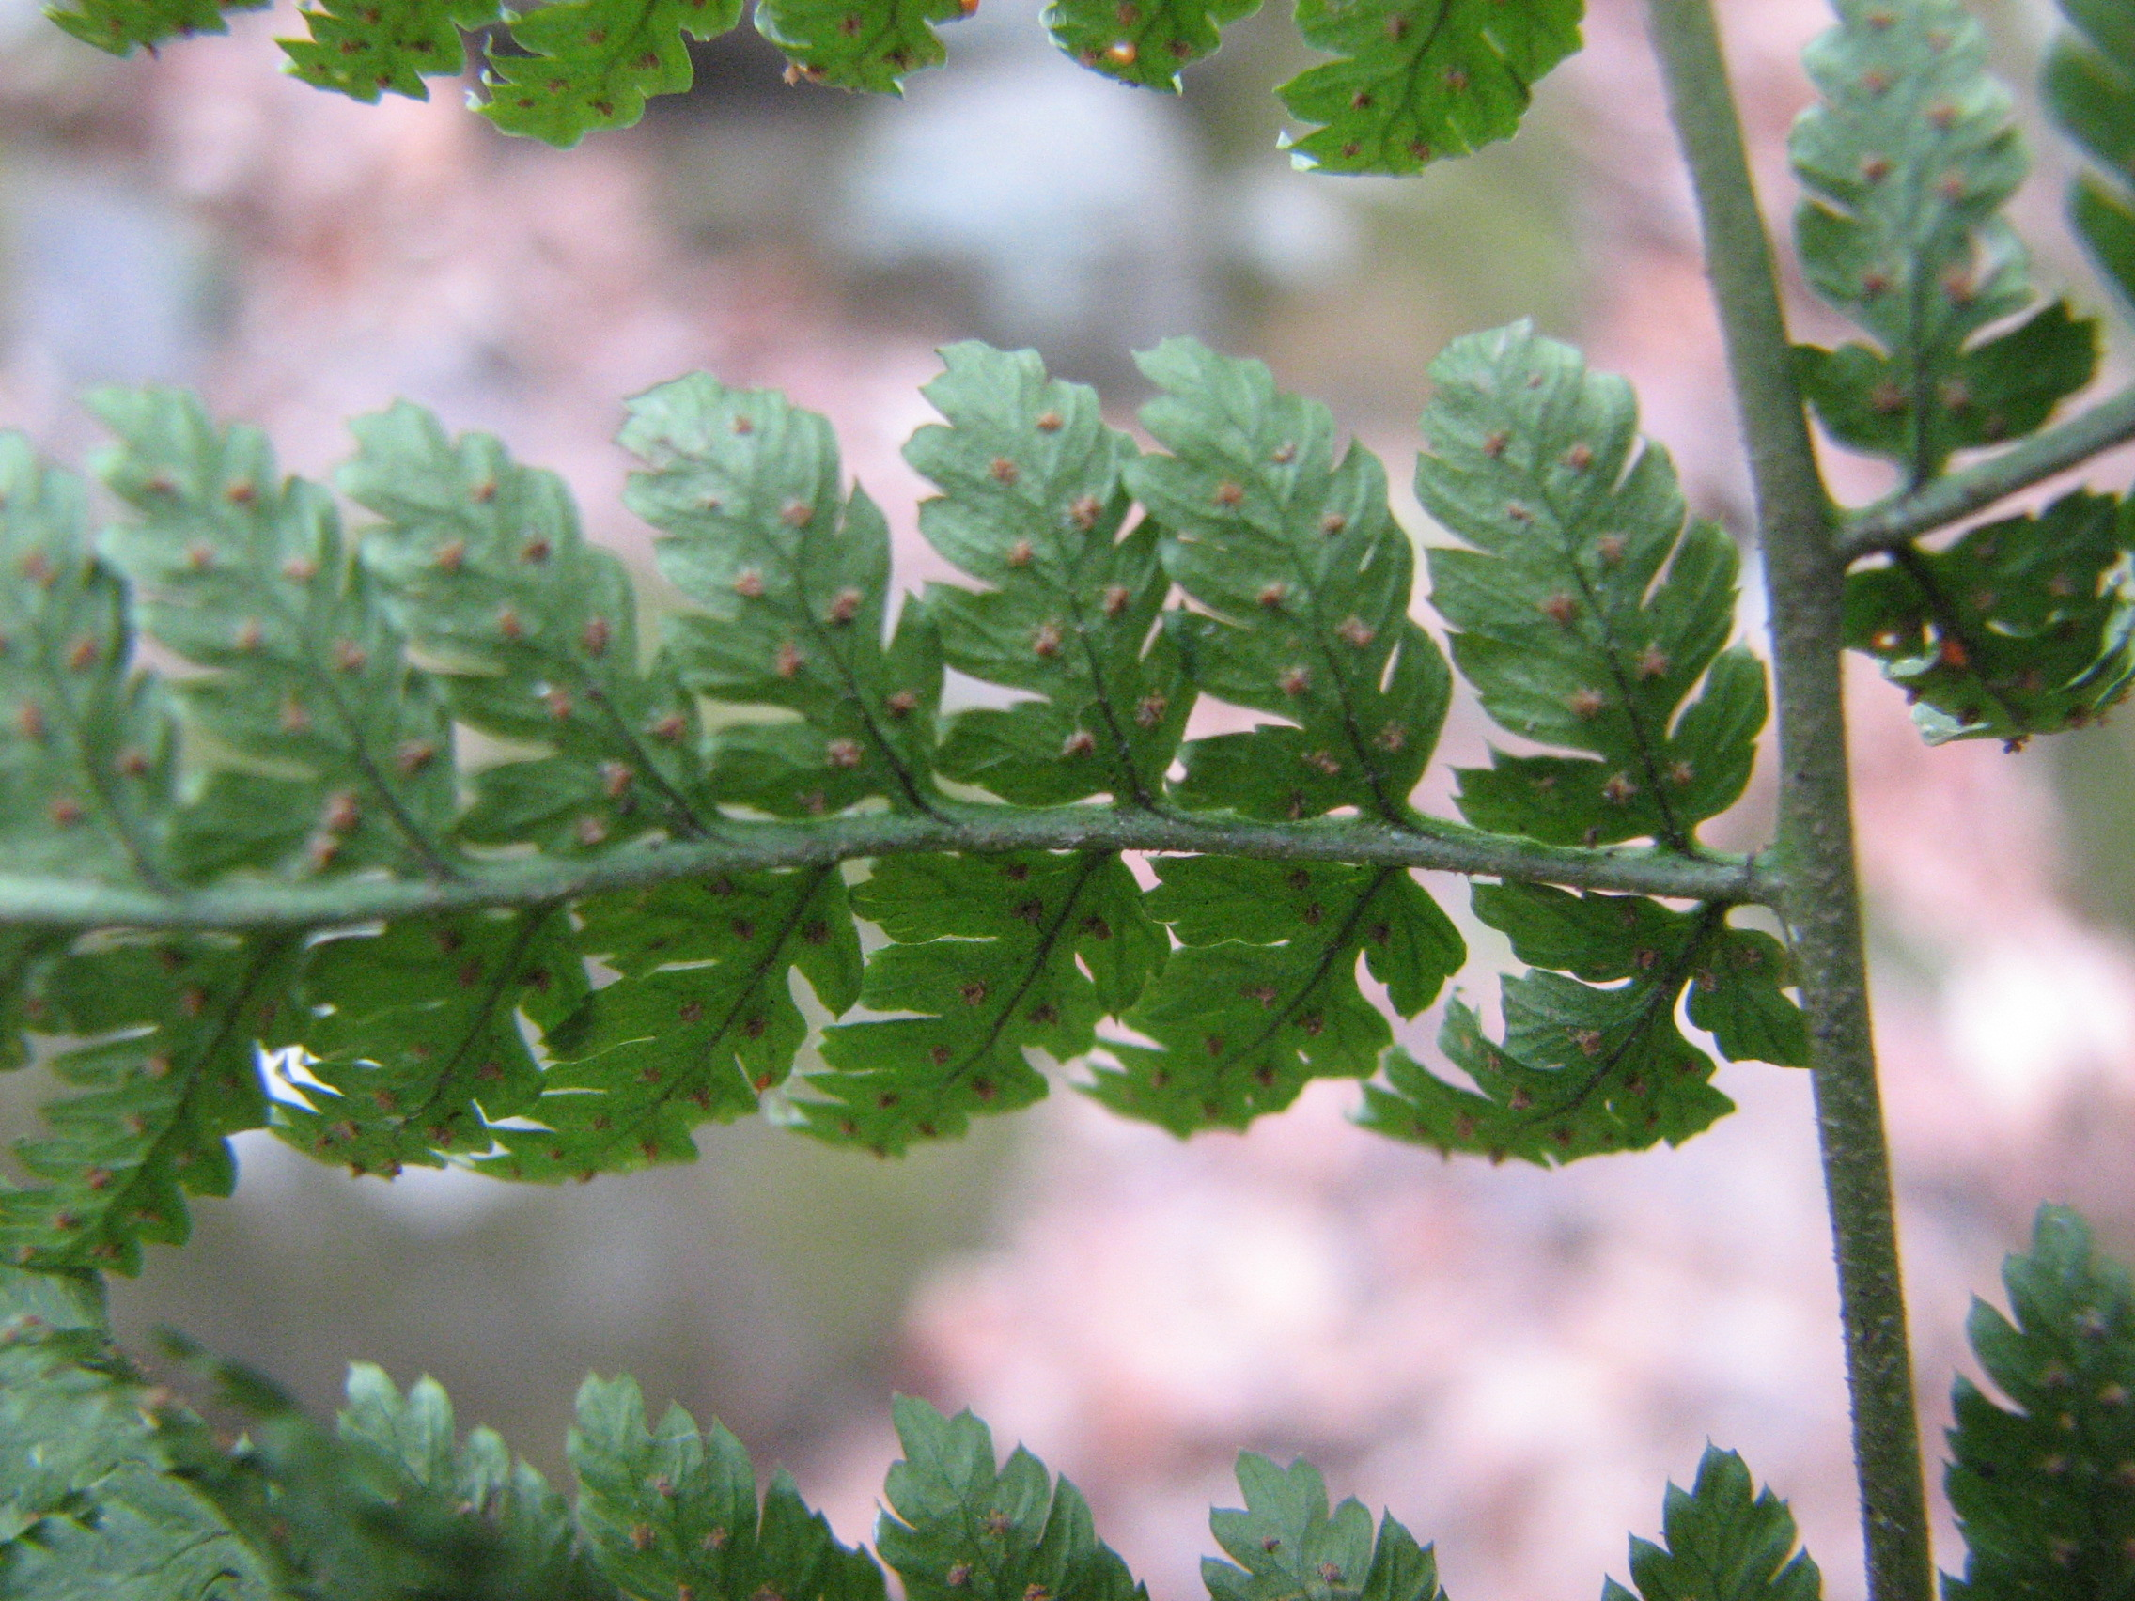Illustration 2: Back of a fertile frond of intermediate wood fern.
If you haven't seen any by the time you reach [marker], don't worry; there will be some at the bottom of the slope later. During your hike in this area, keep your eyes out for the unusual cut-leaf grape fern, Botrychium dissectum. This fern has been reported from the nearby valley of Rocky Run (on the right side as you descended the hill) and may exist on this slope as well. Unlike other Botrychium species, also reported in the area, B. dissectum keeps its single frond during the winter. However, the frond usually turns from green to a bronze color upon the coming of cold weather.

[[[For now, backtrack along the trail until [marker], where the trail dips across the hollow a little rivulet has carved into the hillside. Bushwhack your way down the hillside (not an easy journey except in winter!) Near [coordinate], you should be able to see a large boulder with a flat, rectangular, table-like surface, with a small “garden” of ferns on top. At first glance, they may appear to be small Christmas ferns, but a careful examination of the blade will show otherwise. There are no “thumbs” and the bases of the pinnae are joined to the rachis all along their length. This is, in fact, Polypodium virginianum, the common or rock polypody. As its name suggests, this fern typically grows on rock surfaces rather than thicker soils. Like marginal wood fern, it is almost never found in Delaware outside the Piedmont. More colonies of both rock polypody and the two wood ferns are scattered elsewhere on the steep, trailless slope, often associated with the great boulders that litter it.

For now, if you haven't been able to locate an intermediate wood fern yet, bushwhack back up to the stone wall and the trail. Return the way you came to the abandoned part of Garden of Eden Road, and turn left (downhill). This is part of the Rocky Run Trail, occasionally marked with blue blazes or metal posts. When the trail passes through a pine forest and emerges onto another old road paralleling Brandywine Creek, turn left. This trail will take you along the base of the slope, paralleling the trail and the stone wall above. You will be able to see both species of Dryopteris growing among the rocks of the slope as you walk downstream along the trail. After examining the fertile fronds of several specimens, you will begin to spot the different between the lacier intermediate wood fern and the less heavily dissected marginal wood fern without having to examine sori.]]]

Continue straight along the trail, high along the valley wall. If you haven't picked out a marginal wood fern yet, you can find some at [coordinates]. At [miles], a trail descends down the hillside. Follow it to the wide, graveled trail at the base of the slope and turn right. At [coordinates], look on the right side of the trail for a fern growing out of a rotting log. This is an intermediate wood fern.

Continue to follow the trail along the Brandywine (the Northern Delaware Greenway). To the left is a narrow strip of floodplain forest; to the right are streep, rocky slopes, often rich in beech trees. Cross the bridge over Rocky Run and continue north, through the parking lot on Thompson's Bridge Road and across the road via the pedestrian crossing or the (safer!) underpass. At [miles], pass a knoll on the left (Dumpling Mound) and cross a bridge over a small stream; by now, you have crossed back into Woodlawn Trustees land. On the north side of the stream, there are many rock outcroppings on the right side of the trail. At [coordinates], you should see a large outcropping with a heavy growth of ferns on top. Carefully climb around to examine them. At first glance, they may appear to be small Christmas ferns, but a careful examination of the blade will show otherwise. There are no “thumbs” and the bases of the pinnae are joined to the rachis all along their length. This is, in fact, Polypodium virginianum, the common or rock polypody. As its name suggests, this fern typically grows on rock surfaces rather than thicker soils. Like marginal wood fern, it is almost never found in Delaware outside the Piedmont. These rock-loving ferns can be found on boulders elsewhere in the park as well, but often require extensive bushwhacking to reach.

Ferns of Summer

Other interesting, deciduous ferns can be found in this area during the summer. As you go downhill from the Garden of Eden Road trailhead, take the second right turn off the abandoned road onto a broad trail; it diverges at [distance], downhill from the trail along the stone wall described in the winter hike. As you follow this trail along the hillside above Rocky Run to its terminus at the blue-blazed Rocky Run Trail, be alert for a smaller fern with a blade cut to lobed pinnules. The lowest two pinnae are enlarged and stick off at about a 60-degree angle to one another and to the rachis. If you carefully examine where the pinnae attach to the rachis, you will see leaf tissue forming “wings” along the rachis in a hexagon shape. This gives the fern its scientific name, Phegopteris hexagonoptera; its common name is broad beech fern.

Other ferns reported from the slope above the Brandywine in 1975 are the eastern maidenhair fern (Adiantum pedatum) and the rattlesnake fern (Botrychium virginianum). Found in the Hurricane and Rocky Run valleys, at that time, were a variety of others: southern lady fern (Athyrium asplenoides), cinnamon fern (Osmunda cinnamomea), royal fern (Osmunda regalis), New York fern (Thelypteris noveboracensis), and blunt-lobed cliff fern (Woodsia obtusa), as well as both species of Botrychium. Of these, the first three are water-loving, and, if they remain, can be expected to be found along the streams and the seeps and rivulets that feed them. Blunt-lobed cliff fern is a small, narrow-bladed species that grows on rock faces, while New York fern is a common inhabitant of gaps in open woodland and of wetlands, with characteristic spindle-shaped blades tapering at both ends. (The pteridologist's mnemonic to identify New York fern has traditionally been, “New Yorkers burn the candle at both ends!”) Both areas seem to have suffered ecological degradation since 1975 due to the enroachment of the alien plants Japanese honeysuckle and multiflora rose.

